Series: Christmas in Guangzhou (Winter 2019)/ Requalifying for Premier Silver on United

Red are flights/train rides/hotel stays that I will not report.   
**Bold** are confirmed with a confirmation (has number/code).   
Highlighted are changes to the plan.

1. **United Airlines Boeing 737-900ER Minneapolis to Denver (CPU applied – if upgraded then First Class report)**
2. **United Club Denver-West (near Gate B32)**
3. **United Airlines Boeing 787-8 Denver to Tokyo Narita**
4. **ANA Boeing 767-300ER Tokyo Narita to Guangzhou**
5. **The Westin, Guangzhou (Tianhe location)**
6. Fooding around Guangzhou
7. **Redemption time: Easeland Hotel, Guangzhou**
8. Lights of Guangzhou
9. **China Eastern Airbus A330-300 Guangzhou to Shanghai Hongqiao**
10. **China Railways High-Speed Shanghai Hongqiao to Suzhou**
11. **Courtyard Marriott Suzhou Mudu, Suzhou**
12. **C**hina Railways High-Speed Suzhou-Nanjing
13. China Railways High-Speed Nanjing-Suzhou
14. **China Railways High-Speed Suzhou-Shanghai Hongqiao**
15. **Shanghai Maglev Transit to Pudong Airport**
16. **United Airlines Boeing 777-200ER Shanghai Pudong to Chicago**
17. **United Airlines A320 Chicago to Minneapolis (CPU applied – if upgraded then First Class report)**

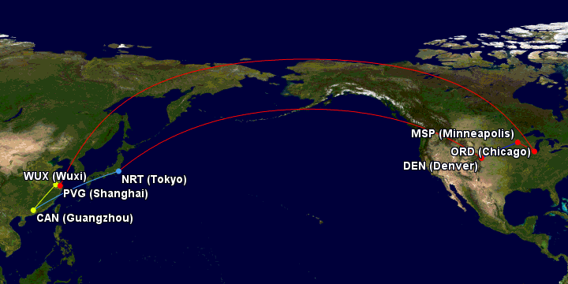

Gcmap.com

Not vlogging. Too much hassle to vlog…

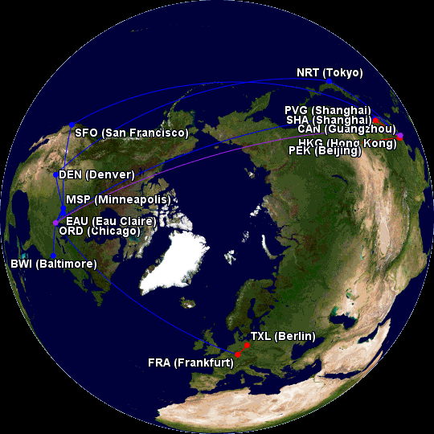

GCMAP.COM